Assignment – 1

(Assignment – Install R base and R Studio on Desktop

Install Swirl and complete the tutorials)

**Installation: R Base**

1. Downloaded the R from <https://cran.r-project.org/bin/windows/base/>
2. Installed the R
3. Launched the R and Using print command

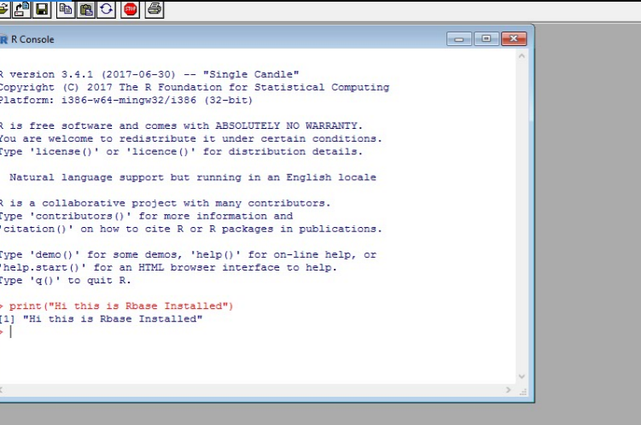

**Trying For Loop In R**

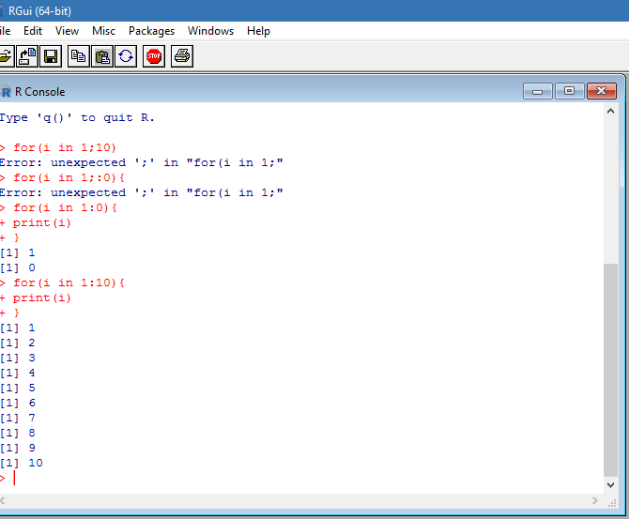

**Installation R studio**

**Installed R studio From** [**https://www.rstudio.com/products/RStudio/**](https://www.rstudio.com/products/RStudio/)

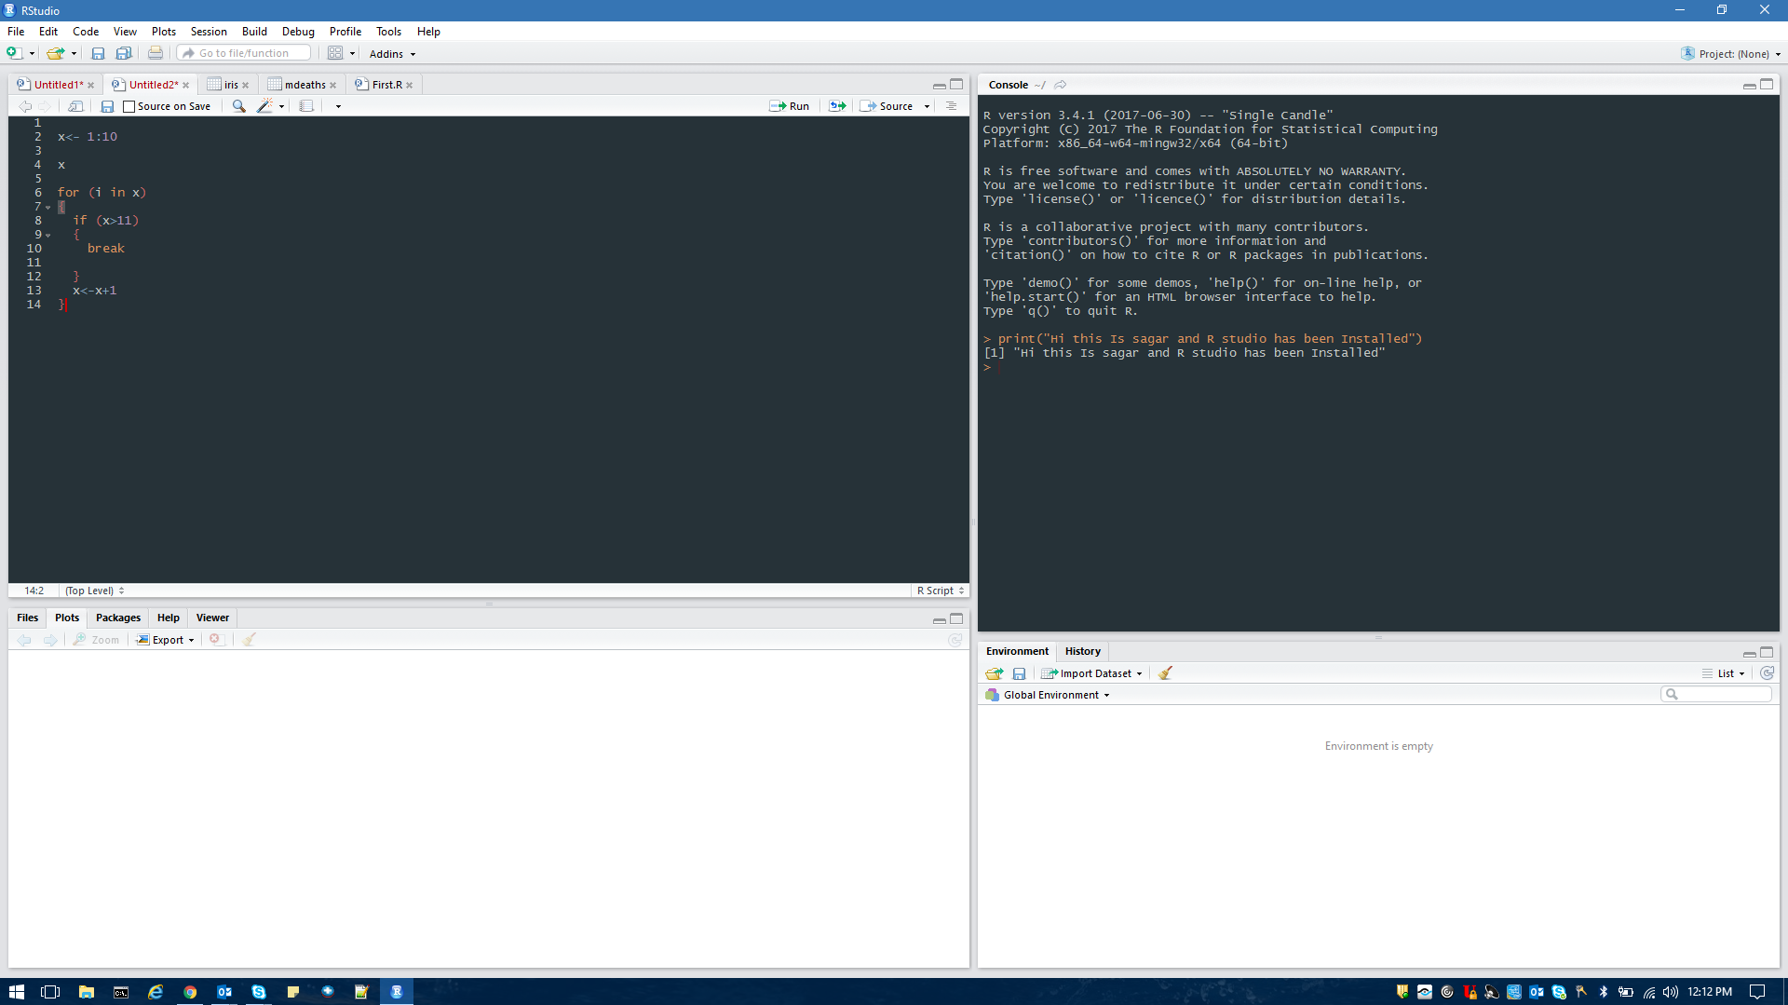

**Installing Swirl**

**Library (swirl)**

**Swirl ()**

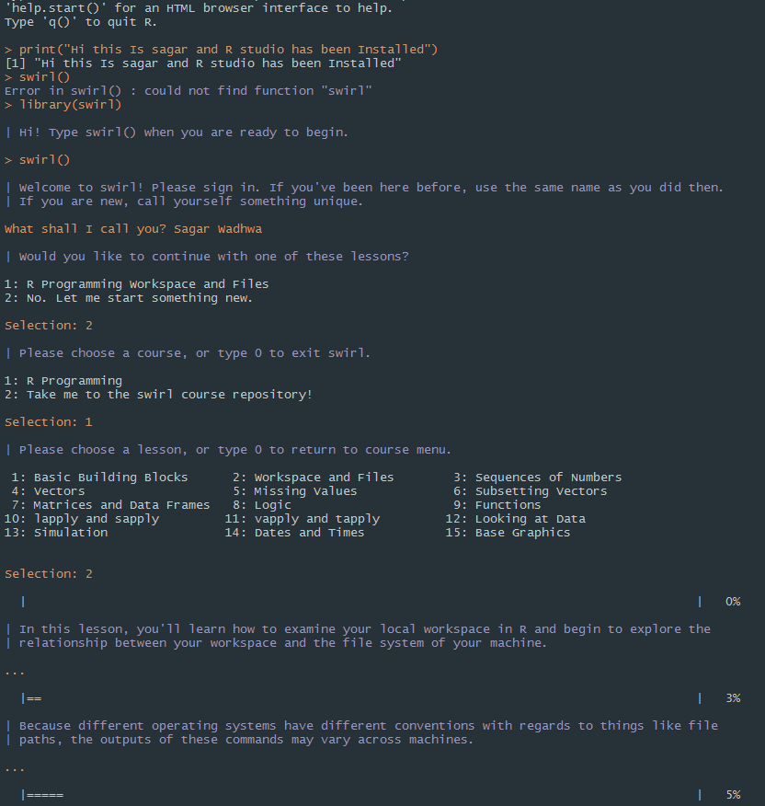

**Playing with Swirl**

**R Programming**

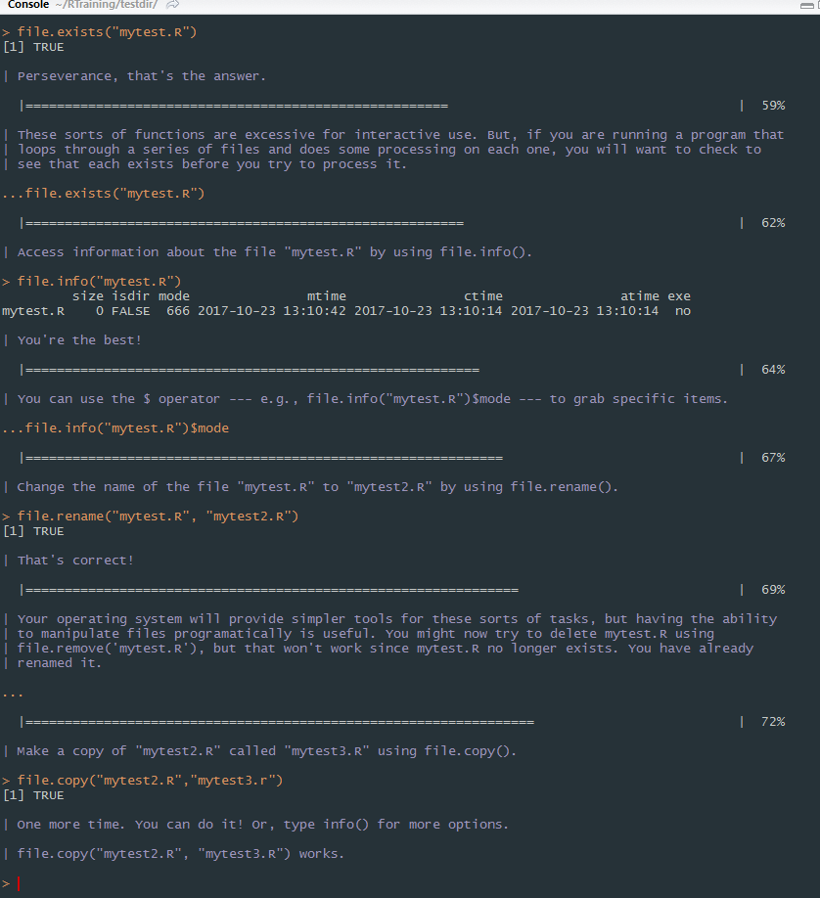

**Learning Swirl()**

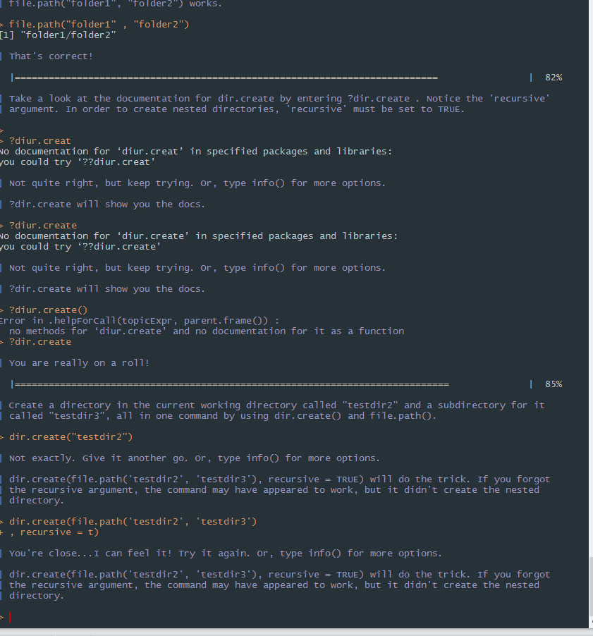

**Nice Tool To learn the R**

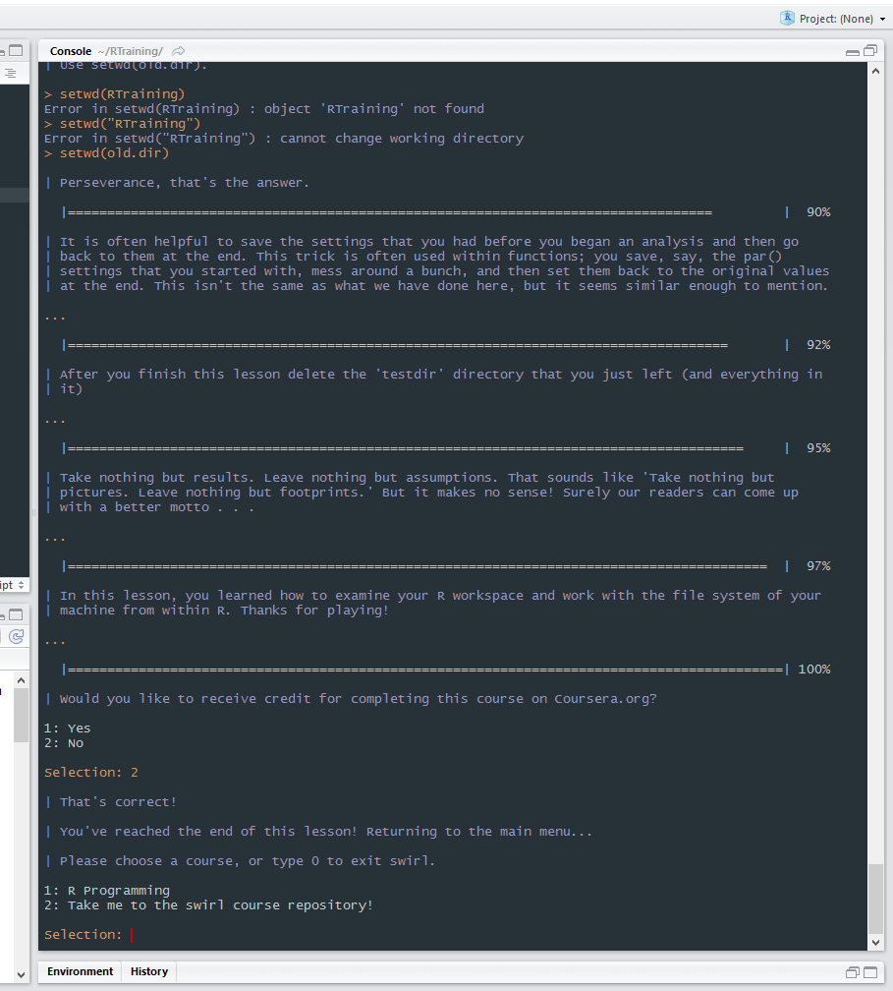

**Swirl()**

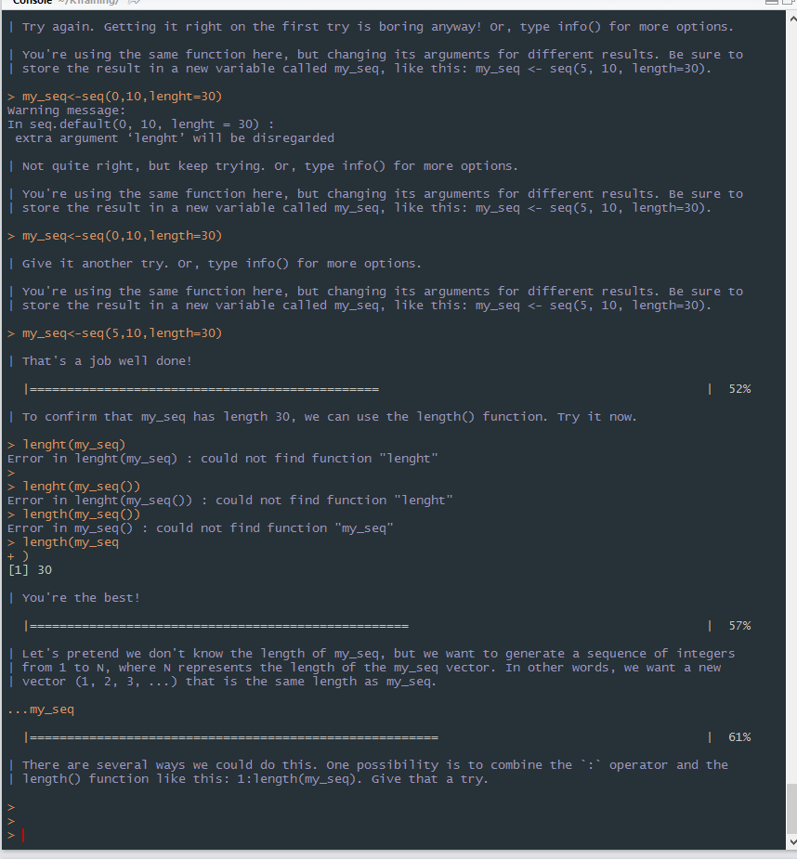

**Submitted by: Sagar Wadhwa**